## 2. ****Active Databases (E–C–A Trigger): Bill Totals That Stay Correct****

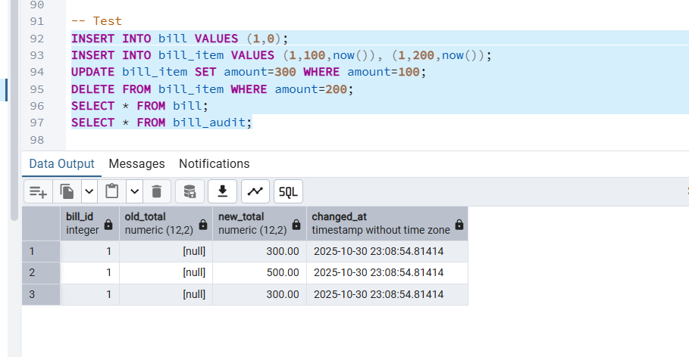

**3️. Deductive Databases (Recursive WITH): Referral/Supervision Chain**

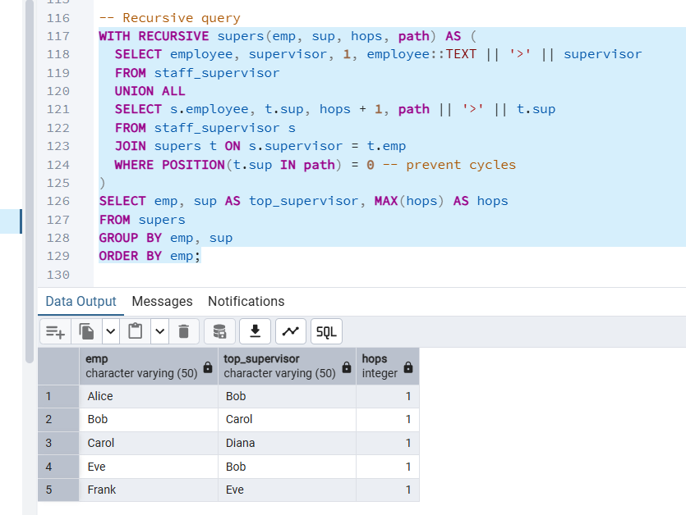

## ****4️. Knowledge Bases (Triples & Ontology): Infectious-Disease Roll-Up****

## 

## ****5️. Spatial Databases (PostGIS): Radius & Nearest-3****

## Spatial Database task for Oracle using SDO_GEOMETRY.

## --The issues in the starter are:

## --Wrong SRID – should be 4326 (WGS84) instead of 3857.Lat/Lon order swapped – Oracle expects (X=longitude, Y=latitude).

## --distance units missing – need 'unit=KM'.

## -- placeholder :AMB_POINT – must define the ambulance location as a

## -- SDO_GEOMETRY point.

## --Corrected Query

## -- Define ambulance location (example coordinates)

## VAR AMB_POINT SDO_GEOMETRY;

## EXEC :AMB_POINT := SDO_GEOMETRY(2001, 4326, SDO_POINT_TYPE(-73.935242, 40.730610, NULL), NULL, NULL); -- Example: New York City

## -- Find nearest hospital within 10 km

## SELECT HOSPITAL_ID, NAME, ADDRESS,

## SDO_NN_DISTANCE(1) AS DISTANCE_KM

## FROM HOSPITAL

## WHERE SDO_NN(LOCATION, :AMB_POINT, 'sdo_num_res=1') = 'TRUE'

## AND SDO_WITHIN_DISTANCE(LOCATION, :AMB_POINT, 'distance=10 unit=KM') = 'TRUE';

## ORDER BY DISTANCE_KM;

## -- Limit to 1 nearest hospital